1 - Development of practical skills worth at least 15% or more of total exam marks from the specification

1.1.1 - 1.1.4 Planning| Implementation |Analysis| Evaluation| skills assessed in a written examination

Give 4 examples of readings and 4 examples of measurements? | Reading  - Thermometer  - pH meter  - balance  - Measuring cylinder  - Volumetric flask  Measurement  - Ruler  - Stopwatch  - Analogue meter  - burette
What are the 2 types of errors? | - Random (eliminated by repeating)  - Systematic
What are standard solutions? | A solution for which its concentration is known accurately
What 3 things should you ensure when making standard solutions? | - Ensure you have clean dry equipment  - Make washings to remove any salt BEFORE MAKING up the solution to the specified amount  - Invert the volumetric flask to ensure everything is dissolved
Give 2 ways of improving an experiment that uses a gas syringe? | - Let the reaction carry on until the gas syringe has stopped moving  - Wait for the gas to cool to room temperature before reading
There is no point writing 0.150 mol dm-3. Writing 0.15 mol dm-3 means the same thing.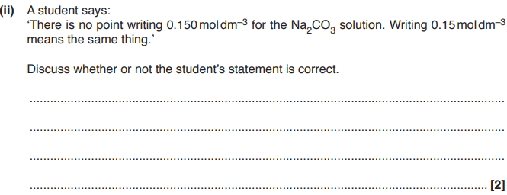 | 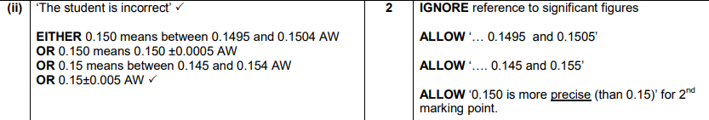  - The student is incorrect (1)  - 0.150 means between 0.1495 and 0.1504  IGNORE reference to significant figures
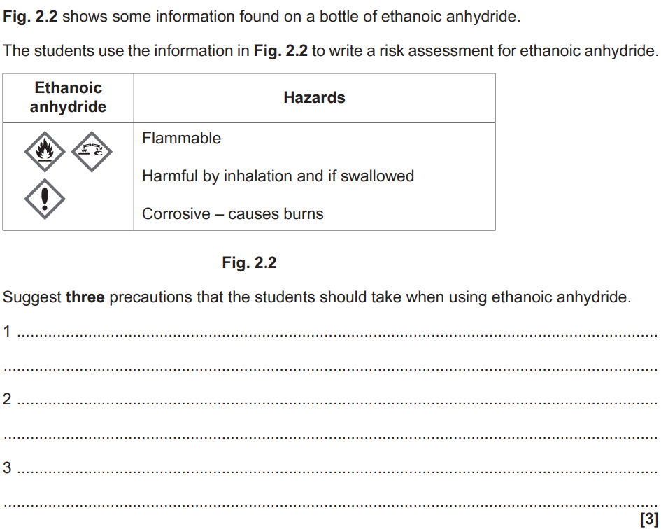  Suggest three precautions that the students should take when using ethanoic anhydride (3)? | - Keep away from flames (1)  - Use in fume cupboard (or well ventilated lab) (1)  - Wear gloves (protective) (1)  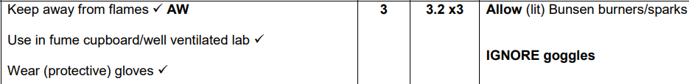

1.2.1 Practical skills | Use of apparatus & techniques| assessed in the practical endorsement

How should you take (not calculate) readings from a burette? | Reading from the bottom of the meniscus at eye level against a constant background  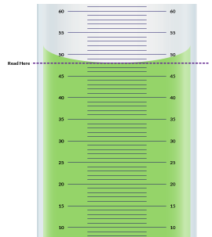
How should burette measurements be recorded | - Should be recorded to 2.d.p  - Should end in 0 or 5  This does not include the mean titre which doesn’t have to end in 5 or 0
What should be done near the endpoint of a titration? | Add the solution dropwise
How should you perform mean titres? | - Repeat titrations until there are two concordant titres (within 0.1cm³)  - Take an average of the concordant titres  - Round to 2 d.p (if required)
By what 4 ways can you heat reactions? | - Water bath  - Electric heater  - Sand bath  - Bunsen burner
By what 2 ways can you purify products | - Solids by recrystallisation  - Liquids by separating funnel or distillation
Why does the student carry out a trial titration? (1)  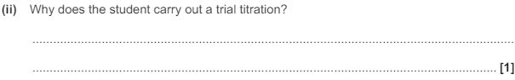 | - To estimate the titre  This is from an AS OCR A 2021 Past paper

